  AI TWINNING, Deloitte and UNCONTESTED MARKET SPACE  T224 Assignment 3 | ID 8830253 | Abstract  Deloitte already owns nearly one-quarter of the estimated $300B revenue from global consultancy services. By 2025, it is estimated that the global AI industry will also be worth around $391B. Scaling from $65B in revenues to $170B in 3 years is entirely possible when your new product offering is not physical.  Roger Hanney  MBA905

List of Contents

- Executive Summary: Deloitte AI Twinning

- Company Overview

- Business Model Analysis

Includes

Customer Market Projection

AI Twinned Consultancy Strategy Canvas

Projected Revenue Model

Business Model Canvas

Projected Growth Rate Comparison

Power – Interest Stakeholder Matrix

- Recommendation

- Appendix

Author’s Note: To properly understand the concept of AI Twinning, please see Reid Hoffman Interviews His AI Twin before reading further.
Link Here: https://www.youtube.com/watch?v=rgD2gmwCS10

- Executive Summary: Deloitte AI Twinning

The consultancy landscape is shifting. Technology is evolving, and client needs are changing. Deloitte, a leader in commercial services, is poised to leverage these shifts for a strategic advantage.

Faced with evolving competition and increasing market demands, Deloitte can establish a first-mover advantage by leveraging its existing knowledge and talent to create uncontested market space through new technologies. The AI Twinning Unit, digitally replicating top talent, is the key. By overcoming limitations of time-zone, language, and availability, Deloitte can scale its expertise in unprecedented ways, setting a new standard for client service, knowledge-based industries and industry-specific insights. Successful implementation could yield benefits more similar to network effects than to traditional rates of growth.

This innovation could rollout in a modified execution of Lean Startup principles, starting small with focus on limited existing customers, validating and scaling rapidly (Ries, 2011). Even now, the Blue Ocean approach of making competition irrelevant by creating a leap in value (Kim and Mauborgne, 2004) is one of the most powerful possible product strategies for any startup. Crucially, a platform-based solution creates opportunity to scale by converting the preferred human interface of personal interaction (atoms – limited availability) into a human-centred new technology product (bits) where the only limits are supply-side investment and market demand.

The proposal promises, sequentially, the benefits of:

Platform Effects: expandable services offering, learning, seamless interaction, adoption.
Scalable Growth: continuous improvement through interaction, feedback, iteration, adoption.
Network Effects: higher usage, greater integration of talent, increasingly valuable service.

As Netscape co-founder Marc Andreessen famously said, "software is eating the world" (Andreessen, 2011). Most of the world’s twenty largest companies are based in tech. It is an essential industry to own real estate and to recruit as a client. Deloitte can use AI Twinning to offer services that are not just faster and more reliable, but also culturally, regionally and linguistically adaptable. This first-mover advantage, as Hoffman noted, is critical in today's fast-paced business environment, "If you aren’t the first to scale, you’ll end up as a footnote in a Wikipedia article about your competitor" (Hoffman and Yeh, 2018). Financial projections suggest a potential revenue surge of $100B, or over 150% to Deloitte within three years. This blitzscaling strategy prioritizes speed to capture market dominance.

Key both to Deloitte’s continuing identity and future commercial advantage is the attraction, retention, and licensing of top talent. By digitally replicating high-level professionals, Deloitte can ensure a consistent, high-quality service while also pioneering a licensing and remuneration regime based on intellectual property and individual identity. This approach will not only empower and attract top talent but safeguard Deloitte’s reputation as a leader in the consultancy industry.

While Deloitte positions itself for dominance in its traditional markets globally, there is a finite opportunity to position Deloitte in uncontested space, where expertise in traditional consultancy meets a new economy that demands rapid scalability and previously unknowable agility.

- Company Overview (From Deloitte’s site, see References List)

Deloitte is the world’s oldest and largest professional services firm. Founded in London in 1845 by William Welch Deloitte and now with over 450,000 employees, the company operates in over 150 countries, providing a wide range of professional services, primarily: Auditing, Taxation, Risk Management, Financial Advisory, Legal Services, Consulting. Key regions are North America, Europe, Asia-Pacific, Latin America and Africa.
Clients range from the Marriott, Hilton, AT&T, Verizon, Nike, ExxonMobil, Unilever, Pfizer, and Walmart, to GE, HSBC, BMW, Coca-Cola the UK Government and the US Department of Defense.

Annual Growth and Financials
Global Revenue for FY 2023: $64.9 billion​​.
Growth Rate: FY23, surged to 14.9%. CAGR approaching 8.5% since 2009.
Expanding Areas: Significant growth in technology consulting, cybersecurity, and AI-driven solutions.
Half of annual revenue comes from North America.
Brand valued at $42B.
AAA+ rating.

Commercial Partners (and Activities)
Google Cloud (cloud, digital transformation), Amazon Web Services (cloud, data analytics), SAP (integrated enterprise solutions), Salesforce (CRM solutions), Oracle (cloud apps & infrastructure), IBM (AI & data analytics, Watson), Apple (mobile solutions), Workday (human capital management

Adoption of New Technologies
Deloitte has historically been an early adopter of emerging technologies, including internet technologies, advanced HR solutions, cybersecurity, digital transformation and blockchain.

Recently, Deloitte has been actively investing in AI research and integration, collaborating with AI leaders like IBM Watson and Microsoft Azure. Importantly, Deloitte recently opened AI research labs in the US and Canada, with work being done on projects related to AI-driven insights, automation, and predictive analytics.

Coupled with a strong focus on ethics, this advanced positioning suggests that Deloitte is already well-positioned strategically – through partnerships, posture, and internal resourcing - to rapidly develop and deploy commercial AI Twinning within its consultancy services offering.

- Business Model Analysis

The business model canvas should come to life on a wall or whiteboard, so a much more detailed BMC can be found in the Appendix in A2 size. The smaller version (diagram follows) should still clearly outline the opportunity that AI Twinning could create for existing customers, new markets, the tech sector for consultancy especially, and of course for Deloitte. Competitive and financial analysis are largely integrated into the BMC discussion.

Customer Segments

Deloitte is already engaged by 88% of Fortune 500 companies. As Christensen highlights, the “job” the customer needs done is critical to innovation. “Understanding the job to be done is the key to making successful products” (Christensen, 2003). By targeting tech and global enterprises, Deloitte can focus on solving complex, high stakes problems in a rapidly growing tier of industry with strong existing relationships and lucrative adjacencies. As they scale, their need for consultancy and financial services will also grow.

Looking at large enterprises (including successful and rapidly scaling tech enterprises) through a JTBD lens, AI Twinning would allow Deloitte to support operational efficiency and strategic decision-making with scalable consultancy services.

LE Pains: High costs of human consultancy, inconsistency in service quality, and delays due to talent shortages.
LE Gains: Cost-effective solutions, consistent quality, timely insights, and scalable services.
Insight: Large enterprises need AI Twinning to ensure they have access to high-quality consultancy services that can scale with their operations without a corresponding increase in costs.

AI Twinning of talent would reduce wait times and booking delays for high value existing clients, the ideal testing ground for product before commercialising more widely and scaling. Value would also be unlocked by ability to support all bookings during peak periods, and especially in the tech sector which is showing the most explosive rates of growth and real dollar values.

Two important groupings to also consider are medium-sized businesses and SMEs, a global sector that is growing as more economies support startups and growth in the SME sector.

Value Proposition

To understand the potential of AI Twinning, watch Reid Hoffman's 2024 video on AI Twinning for an insightful overview. Even in a platform era, people still function emotionally. Being first to market with a comprehensive and highly effective human interface for services essential to business growth would ensure continued consultancy success globally.

Leveraging Deloitte’s extensive talent network and replicating the expertise of leading professionals in key consultancy areas will unlock new possibilities. Using an AI brain trained on an individual’s content, updated as necessary to work in different regions or different languages across different legal regimes, with a human voice and a 4K photorealistic human face, a professional workforce augmented by AI Twins could more easily respond to varying levels of demand. Meeting wait times would decrease, and cost structures would become more predictable.

The key elements unique to this model would be:

- 24/7 availability of human expertise
- Seamless human-AI integration (Brynjolfsson & McAfee, 2014)
- Dynamic adaptation and continuous learning (Ries’ Build-Measure-Learn model in action)
- Ultra-personalised client solutions (leveraging the JTBD framework)
- Predictive and proactive risk management, from financial services to tech and retail (Porter, 1985)
- Enhanced talent attraction and retention (Thiel, 2014)
- Real-time regulatory compliance and adaptation
- Potential to pivot with greater capacity to absorb unanticipated disruption

Channels

Deloitte’s services would continue to be delivered in existing channels and to existing customer networks. The addition of a highly secure AI Twinned consultancy platform network would deliver unmatchable customer experience, even as human meetings move to a different context within a new system. Relationships with leading edge tech firms, many of whom already work with Deloitte, would create unique opportunity for channel experimentation and development.

"Timing is critical. Introduce a product too soon, and it may not be accepted; introduce it too late, and it will be obsolete." (Christensen, 1997)

At some point in the life cycle, app-based solutions may further increase reach, but this could impact a prestige brand perception negatively if not timed and delivered correctly. It might also leave great opportunity on the table if not investigated properly.

Customer Relationships

Large global clients and rapidly scaling tech businesses would receive premium service with top-quality industry expertise available around the clock. Offering top-tier clientele the first opportunity to experience the AI Twin minimum viable product would reinforce its premium status (Ries, 2011).

Medium-sized and smaller businesses could transition to a low-maintenance model, generating revenue without consuming extensive human resources. Prioritizing accessibility and reduced complexity, the iterative process could automate aspects of the AI Twinning solution for clients with repetitive and less complex needs.

Revenue Streams for Deloitte AI Twinning

 | FY23 Revenue ($B) | Projected FY27 Revenue | Contribution to Total FY27 Revenue | Growth Driver
Audit & Risk Advisory | 20.1 | 28.4 | 16.7% | Increased capacity to service large global enterprises
Consulting | 29.6 | 78.2 | 46% | Rapidly growing tech sector and AI integration
Taxation | 10.3 | 28.5 | 16.8% | Enhanced tax advisory and compliance with AI
Financial Advisory | 5.1 | 13.8 | 8.1% | Demand for financial insights and predictive analytics
New AI Consultancy Services |  | 21.1 | 12.4% | Introduction of AI-Driven Insights, Predictive Analytics, Enhanced Cybersecurity
Total | 65.1 | 170

Revenue streams from AI Twinning would primarily be traditional revenues increasing to meet new demand and offer higher level service to existing customers, with high initial outlay, but also significantly higher GP at scale because it is a tech solution. Innovative performance structures, subscriptions, or more traditional retainer models and everything in between would make sense to explore. The revenue would far exceed licensing fees paid to the replicated talent, tech support teams, and cloud service providers.

But there are also unknowable, and reasonably predictable business opportunities that could spin out of this for Deloitte. A professional services company could quickly apply existing skillsets to developing an AI Consultancy, helping existing and new customers to navigate the challenge of strategically deploying AI and associated automation tasks within their businesses.
This aligns with Christensen, “often, products that are not the primary focus of an innovation can turn out to be the real disruptors and valuable new businesses” (Christensen, 1997).

Revenue Streams (Cont’d)

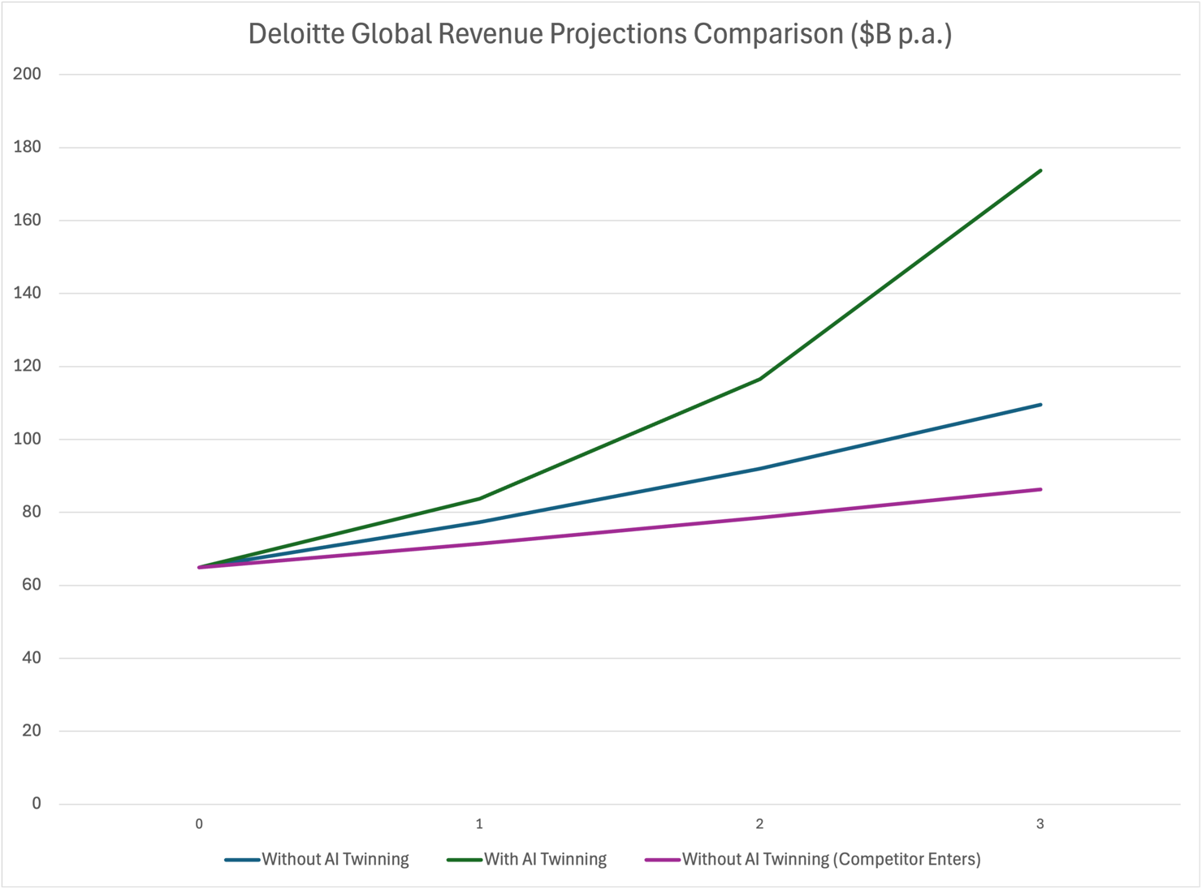

The charted revenue projection above is important not just for its promise of an incredible unlock when an established services business applies itself to scaling like a tech startup. Deloitte already owns nearly one-quarter of the estimated $300B revenue from global consultancy services (Statista, 2024). By 2025, it is estimated that the global AI industry will also be worth around $391B (Grand View Research, 2024).

Scaling from $65B in revenues to $170B in 3 years is entirely possible when your new product offering is not physical.

But it is also important that ceding first-mover advantage in technology markets is like waiting to fail, as has begun to happen in the third scenario, where an existing competitor has developed AI Twinning as an offering first.

Again, (Christensen, 1997) is authoritative, "Being first to market with a new technology can create a significant competitive advantage, as latecomers often struggle to catch up." This was true even before the platform era and it is much more so now. Inaction is a choice with consequences (see also Kodak & Blockbuster).

Competition

As above, it is known that competitors like PwC are exploring AI technologies, and tech companies are exploring consultancy-oriented technological tools. But as the largest consultancy with the deepest talent pool, vast experience, and strong connections to tech research and development, as well as internal AI capacities, Deloitte can leverage an incomparable resource to define and occupy uncontested territory.

Key Resources

"Great companies have secrets: specific reasons for success that other people don’t see. These secrets stem from unique resources or capabilities that are difficult for competitors to replicate” (Thiel, 2014). Deloitte has market-leading talent and the potential to attract almost all of the talent the organisation could possibly need. Coupled with early and ongoing research on cybersecurity and AI, and partnerships with NVIDIA, Microsoft, Google, and AWS, they are well-positioned to make this initiative happen.

Key Activities

Key activities will involve talent identification, negotiation, heavy startup costs for the AI Twinning Unit, a lot of very technical AI activity, client onboarding for limited initial rollout and iterative development before scaling rapidly and as soon as possible. Considering which areas might be better served by first models would be an important early step, for instance clearly defined taxation processes rather than high-consequence risk management or ambiguous commercial discussions.

Legal, marketing, business development would all need to be across the new business opportunity and deeply involved in early through to late stage GTM processes for best opportunities at early success.

Key Partners & Stakeholders

Mendelow’s Power-Interest Matrix effectively captures the stakeholder dynamics of the project. This aligns with Edelman's view that "effective stakeholder engagement aligns their needs with business goals, creating mutual value and driving strategic success" (Edelman, 2020).

High Influence
Manage Closely
Keep Satisfied
Industry Associations, Key Suppliers, Regulators, Government Bodies, Media, Legal
Small Businesses, Local Communities, General Public
High Interest

AI Teams, Consultants, AI Partners, Tech Customers, Investors, Large Enterprise, Regulators, HR

Low Interest

SME’s, NGOs, Researchers, Academics

Keep Informed
Monitor (low effort)

Low Influence

Cost Structure for Deloitte AI Twinning

One of the most challenging but important elements to get right in this process is the model for selecting, negotiating with, and licensing existing top talent. Pitfalls like monoculture need to be avoided, and hazards like workforce concern of being either left out or relegated to less fulfilling work must be anticipated.

"The way to get the best out of people is to make them feel part of something bigger than themselves, a mission or goal that is meaningful and fulfilling" (Sinek, 2009).

The suggested model would see talent receive income additional to their base salary. It could be a flexible model featuring one-off annual licensing fee with some usage conditions to be agreed, a purchasing of their likeness for life (a less likely model), a more frequent payment based on hours in market for the week or the month, with some sort of upper and/or lower limit of payment to be agreed and clearly understood and agreed governance of usage.

Building AI-integrated lifelike human avatars using the deep archives of artefacts – everything from email and Whatsapp messages to blog posts, transcripts, and video – a diverse group of talented professionals would be a fascinating case study in the somewhat chaotic integration of new technologies and old business models.

"Data is the lifeblood of AI systems; without quality data, AI models cannot generate accurate insights." (Davenport and Ronanki, 2018).

Initial outlay would be significant but as with any bits-based business, transactions solve everything and margin is unmatched once critical mass is achieved.

All other costs – hardware, cybersecurity, data acquisition and technology development – would seem initially high before the actual size of market could be established but the potential to more than double revenues within 3 years by seizing early mover advantage is real.

Company Values (Vision)

“Every moment in business happens only once. The next Bill Gates will not build an operating system. The next Larry Page or Sergey Brin won't make a search engine. If you are copying these guys, you aren't learning from them” (Thiel, 2014).

How this program is rolled out and integrated into existing business will determine company-wide success. Real engagement with ethical and existential questions needs to be part of the process, not an afterthought.
Ethical standards would need to be developed, embedded, updated over time. Profit could be taken at the expense of human impacts, but it could also be made at such a scale that strategically skilling and restructuring teams could reinforce rather than harm the bottom line.

All of this would be the stone tablet on which any aspirational vision statement might be carved. That said, as the 6th most valuable brand in the world in 2023, Deloitte would be an appropriate organisation to not just adhere to but to develop the sort of standards and self-regulatory structures early movers will need to anchor from, in the absence of government regulation that reflects an understanding of how these new technologies may be used.

- Recommendations

Deloitte should move quickly to establish an AI Twinning unit that will give them a unique position of leadership as first to market in a new and uncontested market. Quality is frequently defined by scarcity. An ambitious harnessing of newly emerged technologies, existing partnerships and capacities, and top talent to create new economies for talent, existing clients, rapidly growing tech businesses, and major global enterprises would be a bold, industry-changing initiative.

There is a significant opportunity to grow core business through deeper engagement with the rapidly scaling tech market globally. Increased capacity to support customers’ needs during peak periods would also grow customer satisfaction and revenue. Potential growth from media and industry interest could also be significant and there is opportunity to not only own uncontested space but generate additional new business in markets currently untouched by Deloitte but with significant upside likely within a relatively short timeframe.

“When you leverage technology to create new business models, you unlock unprecedented opportunities for growth and transformation" (Hoffman, 2018)

Deloitte is one of the few global brands positioned to not only digitally scale its talent network to meet existing demand, create new market space, and prepare for new markets, but do it successfully.

References List
Andreessen, M., 2011. Why software is eating the world. The Wall Street Journal. Retrieved from WSJ.com.
Barney, J.B., 1991. Firm resources and sustained competitive advantage. Journal of Management, 17(1), pp. 99-120.
Brynjolfsson, E., & McAfee, A., 2014. The second machine age: Work, progress, and prosperity in a time of brilliant technologies. W.W. Norton & Company.
Christensen, C.M., 1997. The innovator's dilemma: When new technologies cause great firms to fail. Harvard Business School Press.
Christensen, C.M., Hall, T., Dillon, K., & Duncan, D.S., 2016. Competing against luck: The story of innovation and customer choice. Harper Business.
CompTIA, 2023. State of the tech workforce.
Cusumano, M.A., Gawer, A., & Yoffie, D.B., 2019. The business of platforms: Strategy in the age of digital competition, innovation, and power. Harper Business.
Davenport, T.H., & Ronanki, R., 2018. Artificial intelligence for the real world. Harvard Business Review, 96(1), pp. 63-73.
Deloitte, 2023. Deloitte becomes the sixth strongest brand in the world in 2024, according to the latest Brand Finance 500 ranking, and remains the most valuable and strongest brand among commercial services. Retrieved from Deloitte.com.
Deloitte, 2023. Global impact report. Retrieved from Deloitte.com.
Edelman, R., 2020. Trust barometer 2020: The state of trust in business. New York: Edelman.
Eisenmann, T., Parker, G., & Van Alstyne, M., 2006. Strategies for two-sided markets. Harvard Business Review.
Fortune Business Insights, 2023. Management consulting market size, share & COVID-19 impact analysis, by service type, by organization size, and regional forecast, 2023-2030.
Freeman, R.E., 1984. Strategic management: A stakeholder approach. Boston: Pitman.
Grand View Research, 2024. Artificial intelligence market size, share & trends analysis report. Retrieved from Grand View Research.
Gulati, R., 1998. Alliances and networks. Strategic Management Journal, 19(4), pp. 293-317.
Hoffman, R., & Yeh, C., 2018. Blitzscaling: The lightning-fast path to building massively valuable companies. Currency.
IBISWorld, 2023. Accounting services industry in the US - market research report. Retrieved from IBISWorld.
International Finance Corporation, 2020. MSME finance gap: Assessment of the shortfalls and opportunities in financing micro, small and medium enterprises.
International Monetary Fund, 2023. World economic outlook, October 2023: Countering the cost-of-living crisis. IMF.
Kim, W.C., & Mauborgne, R., 2004. Blue ocean strategy: How to create uncontested market space and make the competition irrelevant. Harvard Business Review Press.
Kotler, P., & Keller, K.L., 2016. Marketing management. 15th ed. Pearson.
Mendelow, A.L., 1991. Proceedings of the 2nd International Conference on Information Systems. Cambridge, MA.
Organisation for Economic Co-operation and Development (OECD), 2017. Definition of enterprises.
Parker, G.G., Van Alstyne, M.W., & Choudary, S.P., 2016. Platform revolution: How networked markets are transforming the economy and how to make them work for you. W.W. Norton & Company.
Porter, M.E., 1985. Competitive advantage: Creating and sustaining superior performance. Free Press.
Ries, E., 2011. The lean startup: How today’s entrepreneurs use continuous innovation to create radically successful businesses. Crown Business.
Schneier, B., 2015. Data and goliath: The hidden battles to collect your data and control your world. W.W. Norton & Company.
Sinek, S., 2009. Start with why: How great leaders inspire everyone to take action. New York: Penguin.
Statista, 2023. Global information technology (IT) spending forecast from 2022 to 2027.
Statista, 2023. Number of medium-sized enterprises in the United States from 2018 to 2028.
Statista, 2024. Global consulting market size 2011-2024. Retrieved from Statista.
Thiel, P., & Masters, B., 2014. Zero to one: Notes on startups, or how to build the future. Crown Business.
The World Bank, 2020. SME finance.

